1. Arduino Nano V3.0 AVR ATMEGA328P  
   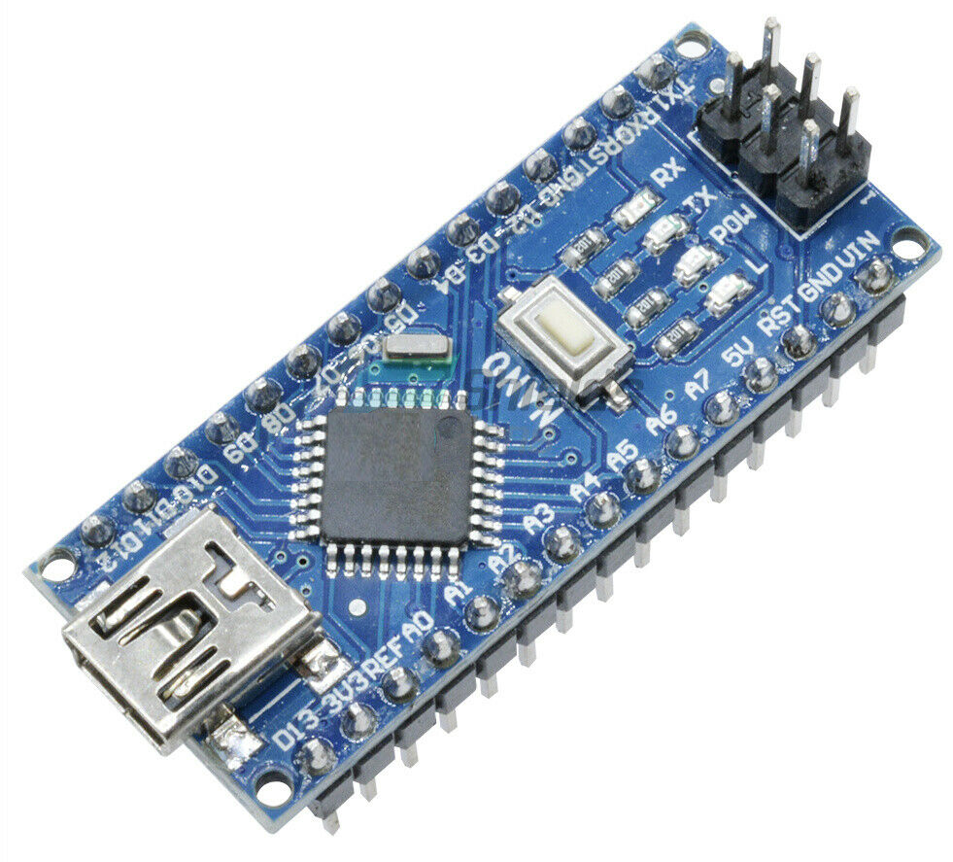
2. Nano Terminal Adapter Arduino Nano V3.0 AVR ATMEGA328P

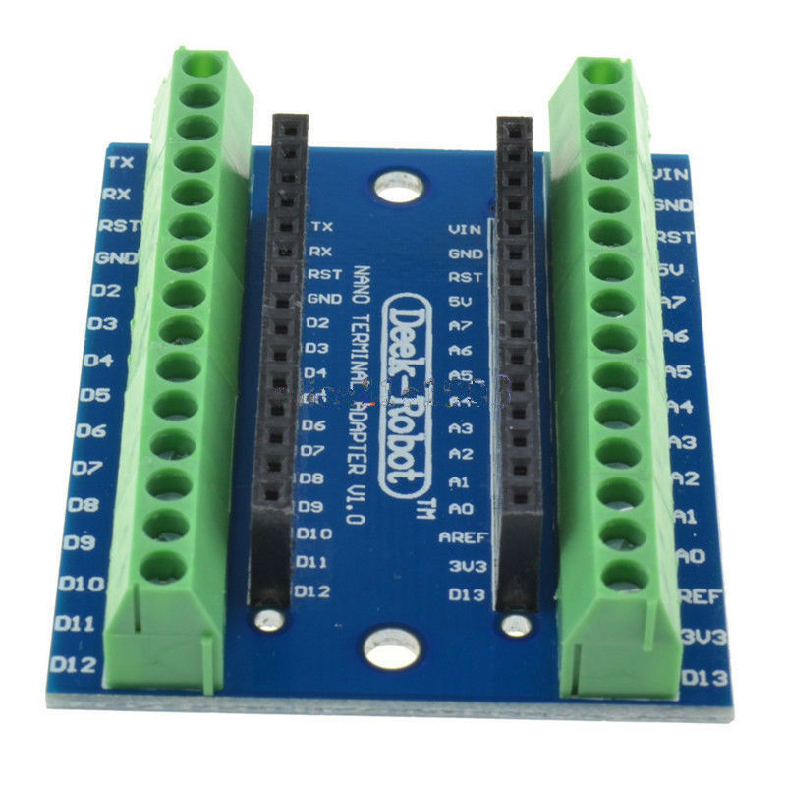

1. B10K OHM Linear Taper Rotary Potentiometer 15mm Shaft With Dial x3

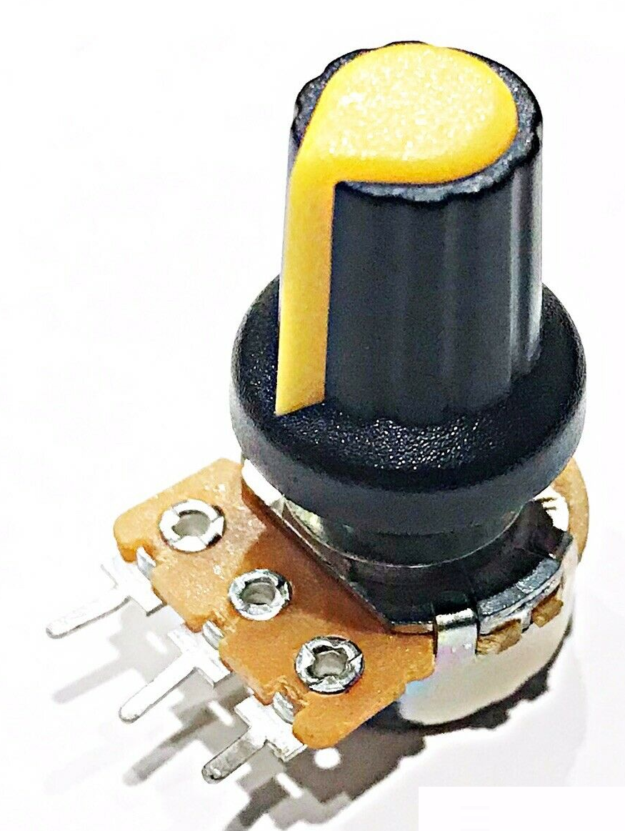

1. 1x Red LED 2V and 1x Green LED 2V 8mm Panel hole

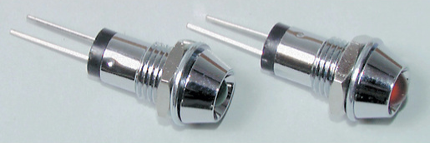

1. 2 x 220 resistors
2. 1 x SPDT Miniature Toggle Switch - Solder Tag

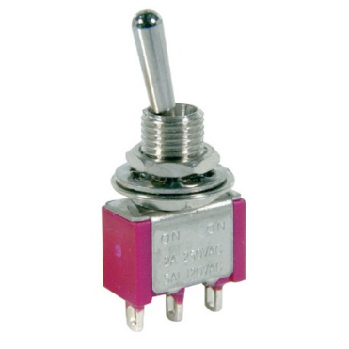

1. 3 x Pushbutton PUSH-ON MOMENTARY SPST RED ACTUATOR 6mm dia

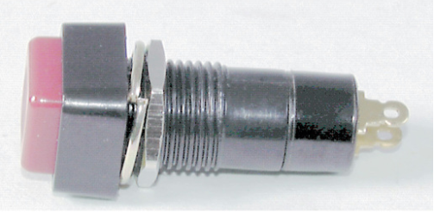

1. Nema23 Stepper Motor – minimum =>2.45N.m

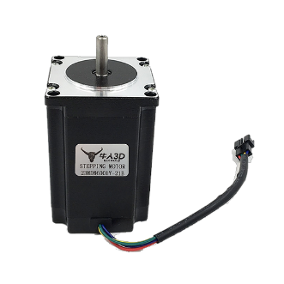

1. TB6600 Driver Single Axis 4A Controller 9~42VDC for Stepper Motor NEMA23

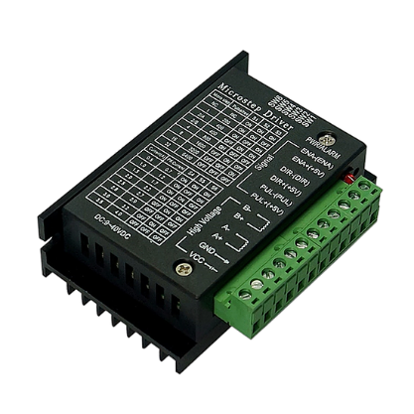

1. 4 Line LCD with I2C backpack
   1. LCD2004 LCD display with I2C module for Arduino

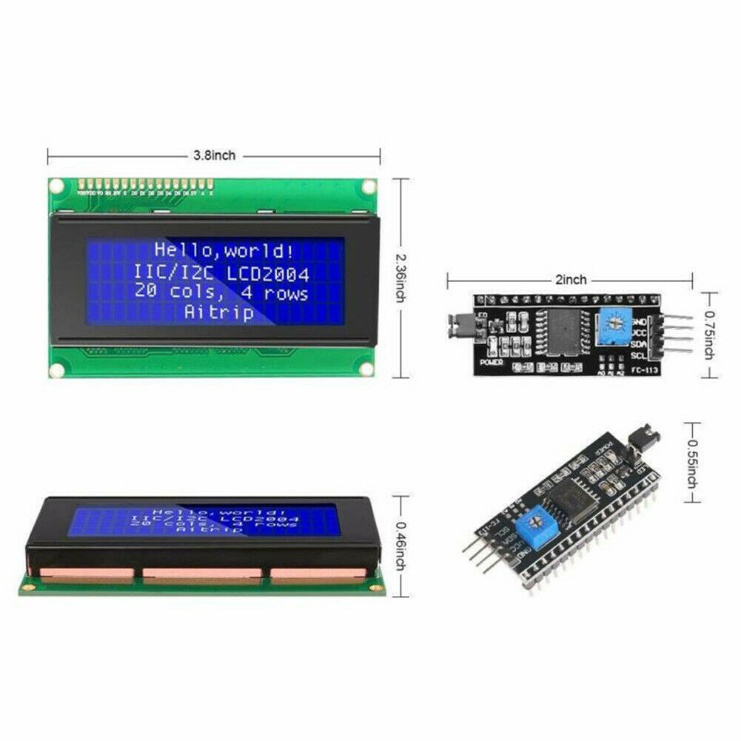

1. SPDT 125V 3A Sub-Miniature Micro Switch with Lever

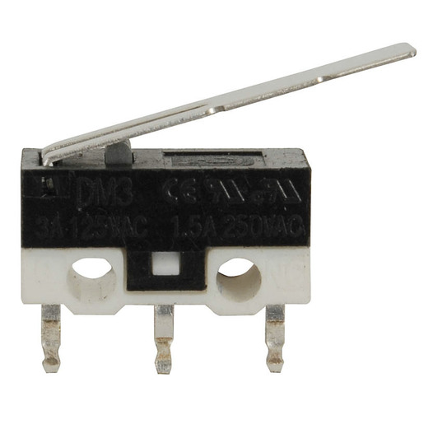

1. Compatible DC Voltage Regulator

•    Input voltage 4.5-35V  
•    Output voltage 3-34V  
•    Maximum output current 2.5A

DC - DC buck converter module Voltage Step Down Converter Module

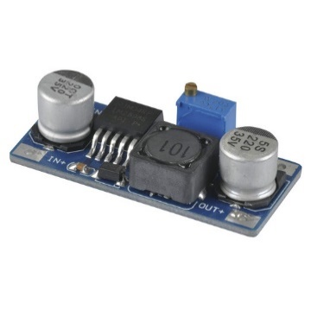

1. 65mm PVC plumbing DWV Straight Coupling

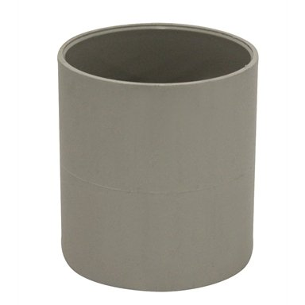

1. Grunt 2mm White High quality braided polyester cord (non-stretch)
   1. Measure 14 inches tie off at 12 or 13



1. 2 medium sized zip ties
2. Lots of different colour wires for joining components
3. M5 x 35mm 316 Stainless Steel Screw Round Head Bolt And Nut - 4 Pack
4. M5 x 80mm Screw Round Head Bolt
5. M5 Stainless Steel Nylon Lock Nut x1
6. Zenith 1/4" And M6 Nylon Washers x6
7. 2mm x 20mm nut and bolt x 2